

**KINGDOM OF LESOTHO**

**Ministry of Social Development**

**INCEPTION REPORT**

VAC HELPLINE SYSTEM

Submitted by



October, 2021

Table of Contents

Acronyms iii

Acknowledgments iv

Executive Summary 5

Introduction 5

Scope 5

Deliverables and Timelines 6

Work Schedule & Milestones 6

Requirements Gathering 8

Participants 8

Day 1 8

Summary table of requirements. 9

Infrastructure Findings and Recommendations 10

Current Infrastructure Setup 10

Proposed Infrastructure 11

Operations and Roles 11

**Partner** 12

**Administrator** 12

**Supervisor** 12

Case Escalation Process 12

Case Categories 13

Reporting Module 13

Pivot Reports 13

Comprehensive Reports 13

Proposed Process Flows 14

Call process flow 14

Case Capture Process Flow. 15

Conclusion 16

Appendix 1: Proposed Case Fields 17

Appendix 2: Proposed Case Categories 18

VAC Categories and Sub-categories 18

Next Steps 21

Sign Off 21

# Acronyms

VAC Violence Against Children

FRD Functional Requirements Document

ACHT Average Call Handling Time

TAT Turn Around Time

QC Quality Control

MNO’s Mobile Network Operators

LAN Local Area Network

UPS Uninterrupted Power Supply

BITZ ITC Bitz IT Consulting Ltd

# Acknowledgments

The BITZ ITC team would like to express our gratitude to all who took the time to speak to us during this exercise.

We were able to conduct interviews with following teams

1. Ministry of Social Development
2. Karabo Ea Bophelo Project,
3. Children’s Court---it is not an acronym
4. Ministry of Home Affairs,
5. UNICEF
6. Ministry of Education and Training

Because of this support BITZ ITC team feels that we are in a position to achieve more over the requirements gathering period. At the same time, we accept responsibility for any errors, omissions, misunderstandings in this report.

# Executive Summary

## Introduction

Child Helpline Lesotho was established in 2008 as an initiative of the then Ministry of Health and Social Welfare (MoHSW) and was initially funded by Global Fund and UNICEF with the objective of handling violence against children’s cases in Lesotho. When donor funding faced out, Ministry of Social Development (MoSD) took over the Child Helpline services.

One of the key components of Child Protection systems is the reporting mechanism by adults and children on incident or risk of any abuse, violence and exploitation happening against any child.

# Scope

Under this assignment, BITZ Consulting Ltd will do the following:

1. The system should be able to receive calls for VAC on the toll free number through an E1 channel.
2. The system should be developed based on open-source standards and technologies preferably on major frameworks such as Laravel, Django, and Spring etc. The process shall be managed and code shared on a code repository such as GitHub with clear documentation on deployment and integrations.
3. Build capacity of the end-user teams to be able to make minor adjustments to the system (configurable modules where possible e.g. case categories, SIP accounts,) and to manage the system after it has been handed over.
4. Develop a universal documented API to enable integration with other 3rd Party systems which will come in the second phase.

API will enable a secure integration with any systems. As it will expose data for consumption in two-ways. External systems will be allowed to consume data from the CHL; the CHL will also be able to access and use data produced by other systems.

1. The solution should be able to handle case distribution, routing, escalation based on roles & permissions regarding access for reported cases. This should include follow-ups, case prioritization as well as case closure by providing necessary assistance to the clients who reach out to the Call Center.
2. Provide dashboard & Reports, real-time call and case analytics with key metrics based on the set Case Categories, Demographics, System Users, Calls, and Call activities.
3. Design and documentation such as:
   1. User Training Manual and Guide
   2. Technical system documentation such as system architecture and technical specifications documentation, system manuals including quick troubleshooting guides and summaries, system administration manuals, guides, configuration, backup and restore procedure manuals
4. Plan and conduct training for: Helpline staff, Helpline Supervisors and local helpline nominated IT focal points and other relevant staff identified.
5. Provide technical support and ongoing routine maintenance for the Helpline, including regular software updates/upgrades for a period of 6 months after the commissioning of the system.
6. Implement security protocols for call & case data and design & set up remote backup, restore & recovery plans, procedures, and systems based on the developed Functional Requirements Document (FRD) taking into consideration confidentiality of the data.
7. Deploy the enhancements on the hosting platform and secure it with a Secure Sockets Layer (SSL) certificate for added security.
8. Project Management. The solution developers shall report to the project manager under Bitz IT Consulting Limited.

## Deliverables and Timelines

### Work Schedule & Milestones

This is an activity assignment to the proposed 35 days project plan from signing the contract to design, develop, deploy and train to handover of the system after sign-off.

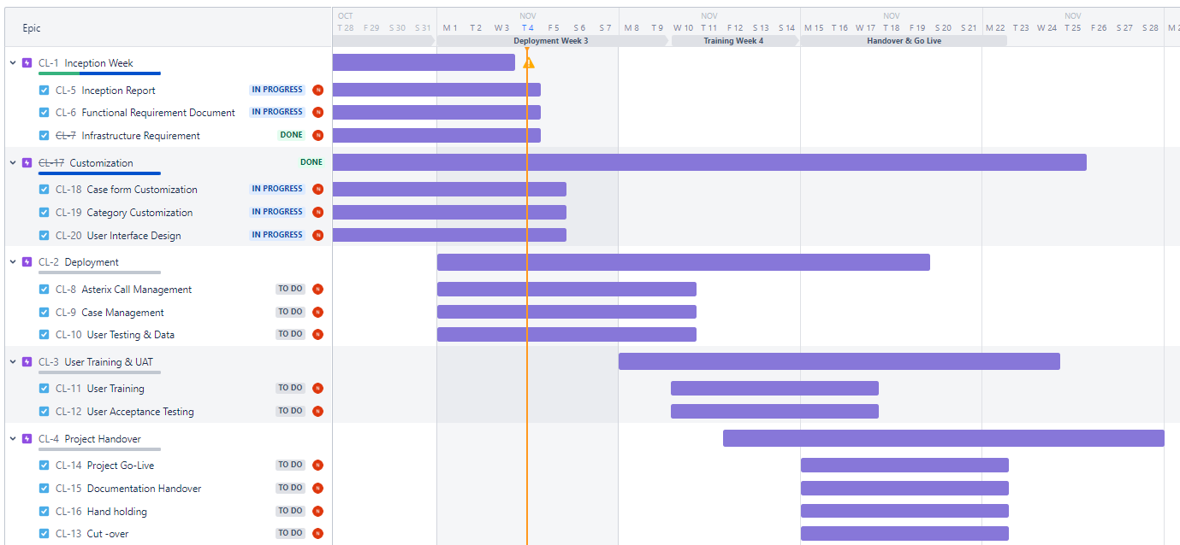

Figure 1: Implementation Schedule/Plan

# Requirements Gathering

# Participants

## Day 1

|  |  |  |  |  |
| --- | --- | --- | --- | --- |
| **Name** | **Organisation** | **Designation** | **Email** | **Tel. No** |
| Rantsala Sanaha | UNICEF | CP Specialist | [rsanaha@unicef.org](mailto:rsanaha@unicef.org) | 58903781 |
| Mookho Motheo | MOSD | Director CP Services | [mookho.motheo@yahoo.com](mailto:mookho.motheo@yahoo.com) | 63604757 |
| Mantoa Sejake | MOSD | Manager CP Services | [man.sejake@yahoo.co.uk](mailto:man.sejake@yahoo.co.uk) | 58733990 |
| Mankuebe Khiba | MOSD | Snr CP Officer | [mankuebe7727@gmail.com](mailto:mankuebe7727@gmail.com) | 58008858 |
| Boitumelo Mofolo | MOSD | CP Officer | [boitumelomofolo16@gmail.com](mailto:boitumelomofolo16@gmail.com) | 58539873 |
| Lerato Phitsane | MOSD | IS Manager | [lerato.phitsane@gov.ls](mailto:lerato.phitsane@gov.ls) | 62599930 |
| Tiisetso Mohlabi | MOSD | Social Development Officer | [tcmohlabi@gmail.com](mailto:tcmohlabi@gmail.com) | 63705232 |
| Tampose Phororo | MOSD | Snr Child Welfare Officer | [phororotampose@gmail.com](mailto:phororotampose@gmail.com) | 67081500 |
| Matseliso Motae | MOSD | Social Worker | [matlhony186@gmail.com](mailto:matlhony186@gmail.com) | 58058424 |
| Mathabo Kopung | Children's Court | Magistrate | [nkhauhele@yahoo.com](mailto:nkhauhele@yahoo.com) | 62784980 |
| Litsoane Keketsi | Home Affairs | District Manager - NICR | [litsoanekeketsi@gmail.com](mailto:litsoanekeketsi@gmail.com) | 58756823 |
| Mathato Nkuatsana | Health | Adolescent Health | [konosoang@gmail.com](mailto:konosoang@gmail.com) | 57040683 |
| Mothakathi Phapano | UNICEF | Senior ICT Associate | [mphapano@unicef.org](mailto:mphapano@unicef.org) | 58848641 |
| Maobert Ramotso | WVL | Child Protection and safeguarding Lead | [maobert_ramotso@wvi.org](mailto:maobert_ramotso@wvi.org) | 58928607 |
| John Mohlouoa | MOET | CP Officer | [nkosijmohlouoa@gmail.com](mailto:nkosijmohlouoa@gmail.com) | 62007488 |
| Mpho Molise | MOLE | Labour Inspector | [makamohelo@gmail.com](mailto:makamohelo@gmail.com) | 58589292 |
| Napo Khuele | Home Affairs | Acting Director-NICR | [ngbkhuele@gmail.com](mailto:ngbkhuele@gmail.com) | 58795552 |
| Moliehi Mokoteli | Probation | Director Probation | [malehakoe.madamane@gmail.com](mailto:malehakoe.madamane@gmail.com) | 63626059 |
| Moseli Ts'eeiso | Probation | Senior Probation Officer | [louistseeiso@gmail.com](mailto:louistseeiso@gmail.com) |  |
| Malineo Motsephe | Letsema Child Rights Network | Secretary | [ma.motsephe@gmail.com](mailto:ma.motsephe@gmail.com) | 58856711 |
| Frank Melato | SOS Children's Villages | School Prinicpal | [Frank.Melato@sos.org.ls](mailto:Frank.Melato@sos.org.ls) |  |
| Kananelo Kutumela | Child HelpLine | Technical Specialist-Child Helpline | [kananelo.kutumela@crs.org](mailto:kananelo.kutumela@crs.org) | 58189158 |
| Lirontso Badela | Child HelpLine | Child Helpline Social Worker | [lirontso.badela@crs.org](mailto:lirontso.badela@crs.org) | 62964482 |
| Mamahali Motanyane | Child HelpLine | Child Helpline Social Worker | [mamahali.motanyane@crs.org](mailto:mamahali.motanyane@crs.org) | 56700205 |
| Thuso Makoko | Child HelpLine | Child Helpline Social Worker | [thuso.makoko@crs.org](mailto:thuso.makoko@crs.org) | 62800030 |
| Nthabiseng Koetlisi | Child HelpLine | Child Helpline Social Worker | [nthabiseng.koetlisi@crs.org](mailto:nthabiseng.koetlisi@crs.org) | 62059299 |
| Thato Mokaeane | KB Project | Senior Data Officer | [thato.mokaeane@crs.org](mailto:thato.mokaeane@crs.org) | 57589445 |
| Malehlohonolo Kuleile | KB Project | M&E Manger | [mkuleile@baylorlesotho.org.ls](mailto:mkuleile@baylorlesotho.org.ls) | 63879135 |
| Limpho Kokome | KB Project | Data scientist | [lkokome@baylorlesotho.org.ls](mailto:lkokome@baylorlesotho.org.ls) | 50223711 |
| Tsepiso Makhetha | Child HelpLine | Child Helpline Social Worker | [tsepiso.makhetha@crs.org](mailto:tsepiso.makhetha@crs.org) | 67376266 |
| Khahliso Makhanoli | Child HelpLine | Child Welfare Officer | [khahliso.mokhaoli@gmail.com](mailto:khahliso.mokhaoli@gmail.com) | 53291727 |

## Summary table of requirements.

|  |  |  |
| --- | --- | --- |
|  | **Problem** | **Proposed Solution** |
| 1 | Call Capacity at the Helpline with addition of calls | E1 or SIP which can handle more concurrent calls. |
| 2 | Knowledge on handling calls | Training and Capacity building required as a key component for the success of this project |
| 3 | Case categories | Bitz shared case categories for VAC as used in Uganda for review by the client. System to allow for creation of categories. |
| 5 | Integration to other systems | This will be done in the second phase. However, the system should have a provision for integration. |
| 7 | Flexibility to generate and Export reports | The system should have an inbuilt reporting engine. with the ability to view based on various metrics & parameters. |
| 8 | Roles & Permission | System will have a predefined permission matrix based to the different key stakeholders (Client to provide) |
| 9 | For IVR if possible let us have Language selection maybe a few of the major languages | The client will provide IVR in different languages. The system should allow for language selection configuration. |
| 10 | Social media reporting and other platforms | The function is available, Social Media and other platforms will be integrated in the second phase. |

# Infrastructure Findings and Recommendations

This is a study of the existing components fundamental to the functionality of the call center both software and hardware.

## Current Infrastructure Setup

The server hardware is as provided below.

* System x3200 M3
* OS: windows server 2008 R@ standard
* Processor: Intel (R) XEON (R) CPU X3430 @ 2.40GHz 2.39GHz
* RAM: 2.00GB
* Type: 64bit OS
* HDD: 250 GB

The center uses GSM/LTE for voice calls. Although the fibre link which is an extension from the government offices is yet to be installed, a VLAN for voice has already been configured within the government network, however, there is no termination to the center and so service remains inactive.

The voice services are currently managed within the virtual LAN (VLAN) within the ministry with a fibre extension from government offices to the call center. A switch with 4mbps is configured for MPLS on the call center. The fibre link has not been fully adopted thus the call center lacks internet and connection to the VLAN.

## Proposed Infrastructure

#### RAM

* Asterisk - 4GB RAM
* Database - 16 GB RAM

#### Storage (HDD/SSD)

* Operating system partition - 100 GB
* Database 100 GB
* Call Recording 1 TB

CPU

* Xeon Processor
* 4 cores 2.0 GHz

#### Operating System

* Centos 8

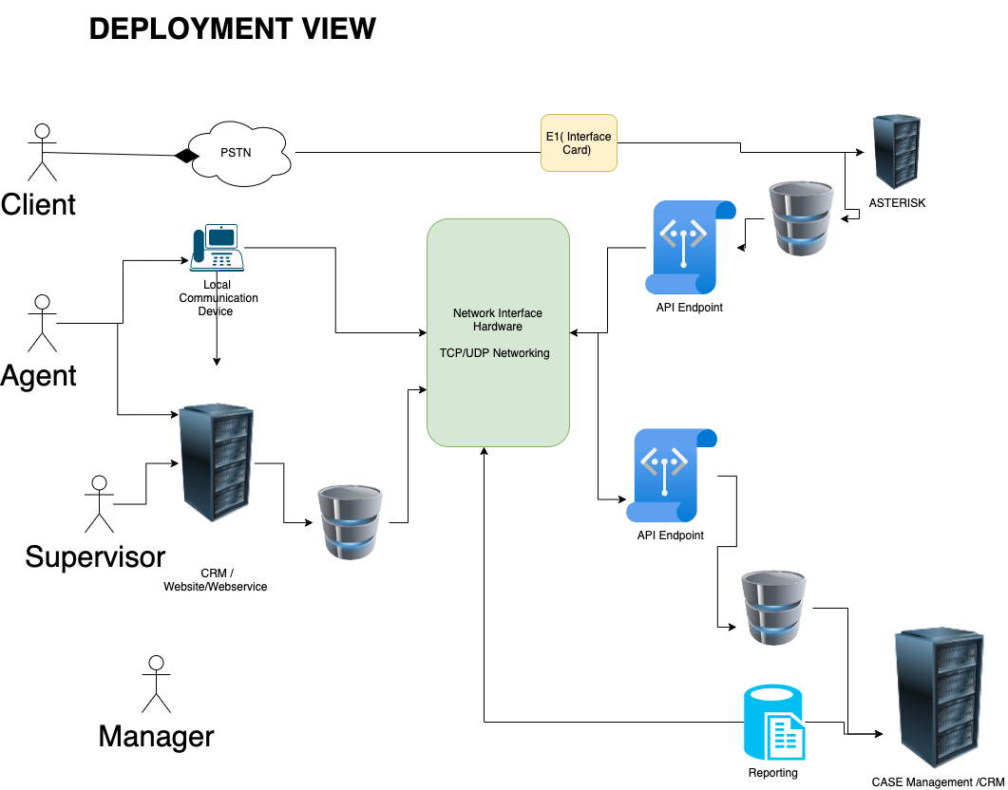

Figure 2: Proposed Infrastructure

# Operations and Roles

The system shall have the following user levels: administrator, counsellor/agent, supervisor and partner.

Every user level shall dashboard representative of their account roles and activity including statistics of calls and cases based on parameters such as categories, status, gender, locations, priority and any other applicable field. The dashboards will also have graphical displays line & pie charts, bar graphs, etc.

## **Partner**

They will be assigned **View** roles so that they can log-in to the system and anytime and view the activities and statistics at the Helpline as may be required. Mostly they will be given access to view reports from the system.

## **Administrator**

This is a general system administrator responsible for general system configurations, they can view cases, they have minimal or no action. The following are some of the roles by administrators:

* Create and update configurable parameters such as case categories and services offered.
* Manage system users.
* View reports.

**Child helpline Social workers**

Child Helpline Social Workers handle calls and are mainly based at the call center. They are trained to offer first-line support for both VAC. Additionally, they:

* create cases from calls
* escalate cases to supervisors
* View their own cases.
* Can search cases from all cases

## **Supervisor**

A supervisor is the call center manager who is in charge of counsellor/agent work affairs and to ensure they are within the set policies of the helpline. They:

* Can create cases.
* View all cases with an option to update.
* Perform QA on calls.
* Propose system settings and updates to the administrator.

# Case Escalation Process

This is the process in which a case goes through before it is closed. A case may be closed at the time of creation by the counsellor but sometimes it requires attention from a higher level of the user hierarchy.

Helpline Social workers escalate cases they are not able to resolve to supervisors who are always the center managers for further action.

After these roles were defined Case capture flow was also discussed. Seven broadly classified tabs for the information to be captured were proposed.

1. Case Reporter Details
2. Case Category
3. Other Client Details
4. Perpetrator Details
5. Case Narrative
6. Services Offered
7. Case Action

Depending on the case status if the client is a first time Reporter the counselor would click on Create New case otherwise if the client is a repeat Reporter/ Client the form should populate their details accordingly.

# Case Categories

BITZ ITC shared the list of generic categories with the client. The initial categories will be uploaded into the system at inception, however, the system allows for additional categories

**Appendix 2** outlines the various proposed Categories for the VAC which the consultant will continue to work with the stakeholders to harmonize.

# Reporting Module

All activities done on the case management system will result in reports which are used by the supervisors, managers, and others to analyze the trends and be proactive and take corrective measures to mitigate situations. Both call and case reports shall have a list and statistical (pivoted) reports.

### Pivot Reports

Pivot report refers to the statistical description of the data captured generated by a system user based on select report fields. It presents fields on an X and Y axes form and is filtered by date and/or date range.

This gives a permeation & combination of the type of reports required and the different data required. Additional fields can be provided for filtering the reports. This applies to both call and case reports.

The report should be printable or exportable to acceptable formats such as PDF or spreadsheet.

### Comprehensive Reports

These are the main types of reports with listings of records are collected by the system. The module should provide filters for all of these kinds of reports to allow users get what is needed for a particular purpose. The filter may include date created, location, categories, gender, and status among others.

These reports include:

* Call Reports
* Case Reports
* Counsellor Reports
* Performance Reports

The comprehensive reports shall have export option to formats such as XLSX, CSV, XLS and PDF either for further analysis or presentation.

# Proposed Process Flows

## Call process flow

Welcome IVR

Call Answered?

Exit IVR

Voicemail?

Case Capture/Follow Up

Voicemail message IVR

### 

## Case Capture Process Flow.

This shows the flow of the case capture process. The reporter details can be prefilled on call if the details exist and for all historical cases.

New Case

Reporter details

Information Inquiry

Client Details

Perpetrator Details

Case Details

Services Offered

Case Action/Closure

Follow Up

# Conclusion

The existing infrastructure and the current system require a complete overhaul. The CHL systems provide a perfect opportunity to improve the process at the CHL center. Eventually, we expect that the volume of calls and cases at the helpline to increase exponentially.

With all the stakeholders working together we believe that the consultant will successfully deploy the envisaged system in the timeframe provided of 35 days.

# Appendix 1: Proposed Case Fields

|  |  |  |
| --- | --- | --- |
| # | Grouping | Field(s) |
| 1. | Report Details | Name, gender, phone number, language, Age Group, location (hierarchical), Nearest Landmark( e.g. school /mountain/church) ,  Alternative Contact (Text Field)  Email Address (Text Field), alternative contact, nationality and ID |
| 2. | Case Categorization | Case Category (Select Categories), case subcategory (select sub categories), if reporter is client (reporting for self) |
| 3. | Client Details *(Collected if the reporter is different from the client)* | Name, gender, phone number, language, Age Group, nationality, location (hierarchical), Nearest Landmark,  Alternative Contact (Text Field)  Email Address (Text Field), relationship to reporter, relationship comment, health status |
| 4. | Additional Client Details | DOB (Date of Birth),Age (in months and years),Guardian name, guardian marital status, disability status, disability type, if referred to receive special services, HIV status, household type, number of adults in household, occupation of household head, if client attends school, name of school, client school level, type of school, school attendance, school attendance reason, school address, if client is married, spouse name, spouse profession |
| 5. | Perpetrator Details | Name, gender, relationship with client, if the perpetrator share household with the affected person, location (hierarchical), Nearest Landmark, age, age group, perpetrators guardian name, tribe, health status, marital status, additional details |
| 6. | Case Narrative | Narrative, case plan, status in the justice system, general case assessment, related files, priority |
| 7. | Services Offered | Services offered, appropriate referrals |
| 8. | Case Action | Case action (status), status comment, how one got to know about 116 |

# Appendix 2: Proposed Case Categories

N.B. This is the generic list of the helpline categories as provided by BITZ ITC.

## VAC Categories and Sub-categories

|  |  |  |
| --- | --- | --- |
| # | Category | Subcategory |
|  | Abuse | |
| 1. | Murder | * Child Death due to Abuse * Attempted Murder * Child Sacrifice * Concealment of birth * Mysterious Death * Poisoning * General |
| 2. | Physical Abuse | * Corporal Punishment * Electric-shocking * Beating * Burning * General |
| 3. | Emotional Abuse | * Labelling * Witness to Violence/Abuse * Bullying * Verbal Attack * Stigma and Discrimination * General |
| 4. | Child Trafficking | * Internal Trafficking * Cross Border Trafficking * Abduction/Kidnapping * General |
| 5. | Child Exploitation | * Child Labour - Commercial * Children used for Criminal Activity * Children used for Begging * Child Labour - Domestic * Child Labour - Bonded * Child Labour * Commercial Sex Exploitation * Herders * General |
| 6. | Child Neglect | * Denial of Education * Child Malnutrition * Child Abandonment * Child Maintenance * General |
| 7. | Sexual Abuse | * Defilement * Exposure to Pornographic Materials * Sodomy * FGM (Female Genital Mutilation) * Teenage Pregnancy * Early/Forced Marriage * General |
| 8. | Online Child Sexual Abuse And Exploitation | * Online Extortion and Blackmail * Victim of Online Sexual Exploitation * Exposure to Online Child Pornography * Victim of Online Child Pornography * Attempted Defilement * Online Grooming for Sexual Purposes * Unwanted Sexting * Revenge Pornography * General |
|  | Counselling |  |
| 1. | Boy/Girl Relationship |  |
| 2. | Student or Teacher Relationship | * Teacher Problems * Student in Problems with School Authority * Concealment of Birth |
| 3. | Stress/Depression |  |
| 4. | Self Esteem |  |
| 5. | Reproductive Health Issues |  |
| 6. | Loss and Grief |  |
| 7. | Career Guidance |  |
| 8. | Juvenile Delinquency |  |
| 9. | Family Issues | * Divorce/Separated Parents in Conflict * Sibling Relationship * Family Member in Conflict |
| 10. | Parent or Child Relationship | * Unmanageable Children |
| 11. | Parental Guidance | * Positive Parenting * Coping with Single Parenthood |
| 12. | Peer Influence |  |
| 13. | HIV Counselling |  |
| 14. | Child Custody | * Institutionalization * Adoption * Paternity/Maternity Rights |
| 15. | Child In Conflict with the Law | * Child Imprisonment * Juvenile Delinquency * Child to Child Sex |
| 18. | Addiction | * Drugs * Smoking * Alcohol * Gambling * Gaming * Pornography * Social Media/Internet * Food * Masturbation |
| 19. | Mental Issues |  |
| 20. | Legal Issues | * Child in need of representation * Child Witness * Law in Conflict with Children's Rights * Child in Conflict with the Law * Child Imprisonment * Child Imprisoned with adult Person * Pre-Trial Briefing * Child Maintenance, custody and Access |
| 21. | Child to Child Sex |  |
| 22. | Lost Child | * Seeking shelter * Missing Child * Homeless Child * Lost Child |
| 23. | Life Skills |  |
| 24. | Property Rights | * Inheritance issues * Property grabbing |
| 25. | Persons with Disabilities | * Deaf * Visually Impaired * Mental Disability * Physical Disability |
| 26. | Orphans | * Child headed families * Orphan in need of care and support * Orphan in need of school fees * Orphan living with elderly person * Orphan living with HIV-Infected person |
| 27. | Street Child |  |
| 28. | Discrimination | * Age * Ethnicity * HIV/AIDS * Marginal/Vulnerable Groups * Criminal Record/Ex-Prisoner * Access to Education * Albinism |
| 29. | Run Away Child |  |
| 30. | Medical Aid | * In need of medical assistance * Access to health care * Concerns about illnesses |
|  | Information Inquiry | |
| 1. | Pre-trial Briefing |  |
| 2. | Inquiry on Other Services |  |
| 3. | Information on Helpline Services |  |
| 4. | Financial Aid |  |
| 5. | Employment/Job |  |
| 6. | Topical Issues (Child rights, Biology etc) |  |
| 7. | Case Update |  |
| 10. | Birth Registration |  |
| 11. | Appreciation |  |
| 12. | In Need of School Fees |  |

# Next Steps

After conclusion of our finding we have compiled and documented the Functional Requirement Document. In this document we have indicated the key areas of the solutions that our teams will implement.

With all factors remaining constant the key milestone as indicated on the project schedule, will be completed in the next 5 weeks.

# Sign Off

|  |  |
| --- | --- |
| By signing this document, I acknowledge that I have received stated deliverables to the agreed quality levels. | |
|  | **Signature:** |
| **Date:** |
|  | **Signature:** |
| **Date:** |
|  | **Signature:** |
|  | **Date:** |